Sticker detection

1. Detect sticker blocked by check how the color of sticker changes :

① Manually input the coordinates of the four vertices of the rectangle box, which can include the circular stickers.

② Set sticker color without blocked as original color

③ check once every 100 frames, if the average color in the frame changes and the change variable is greater than the given threshold, then the sticker is blocked, and the video segment is cut off as a highlight.

④ When the sticker is blocked by the player rather than the racket, we can determine the two by adjusting the threshold value of color change because they have different effects on the color change of the sticker area.

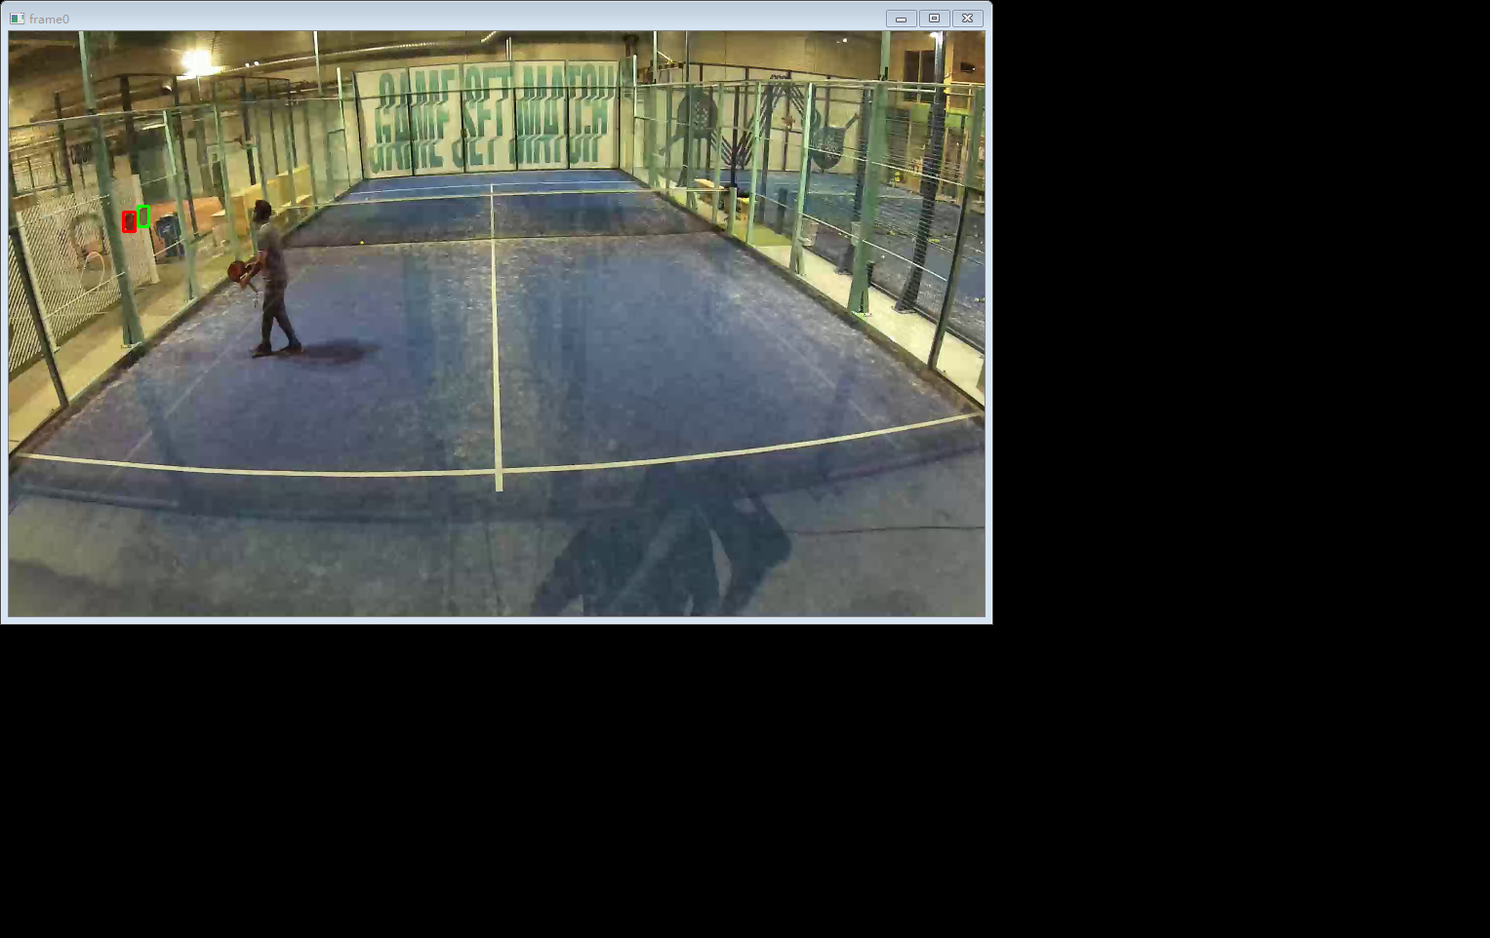

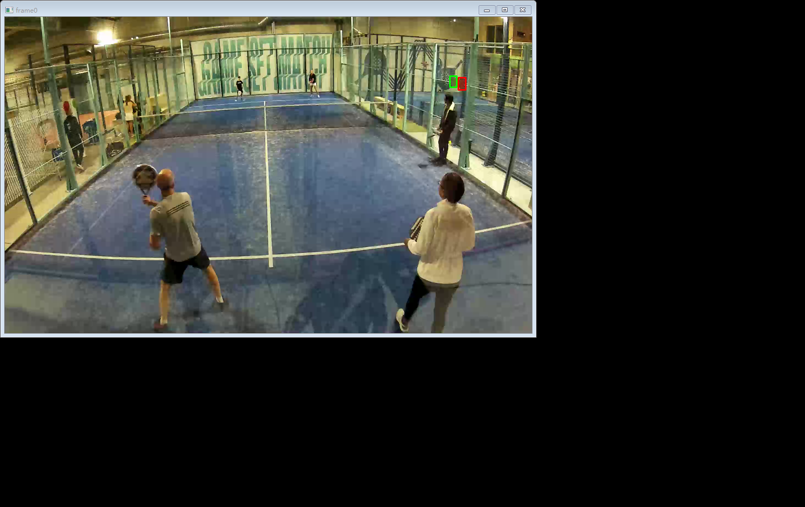

1. Cut video clips in live video:
2. When serve been detected (to be implemented), video segment begin
3. When sticker block been detected, video segment stop, here are some clips saved

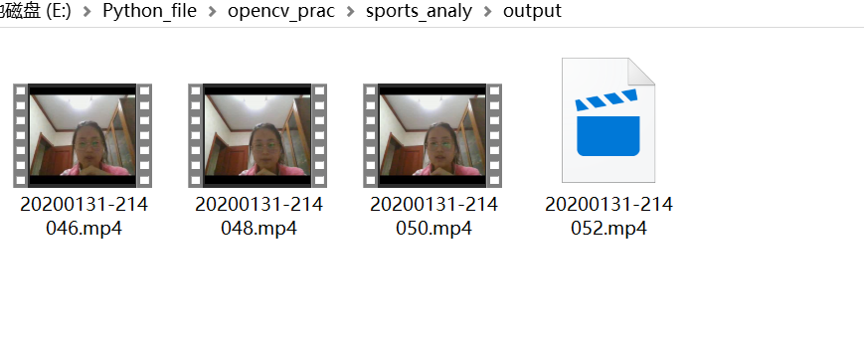

1. Score counting: overlay the score on the screen

